WEST HAM UNITED
OCEANIA ACADEMY

2018 PLAYER ID CAMP

HOST PARTNER

Kunda Park, QLD

Monday 9th - Tuesday 10th July 462 Maryoochydore Road, Kunda Park, QLD, 4558
Cost $180 (includes a camp t-shirt)
Boys & Girls: Ages 7 -17
SESSION TIMES

10.00 am – 2.00pm (Lunch break 12.00 – 12.30pm) BRING A PACKED LUNCH, WATER BOTTLE AND SUNSCREEN

•Genuine West Ham Academy Coaches
•Selected Players Invited to West Ham Australia National Camp (Four Day Residential Camp on the Gold Coast in September)
•Assistant Academy Director will Oversee National Camp
•Selected Players invited to spend a week at the club in London
•Selected Players invited to take part in West Ham UK Development Tour

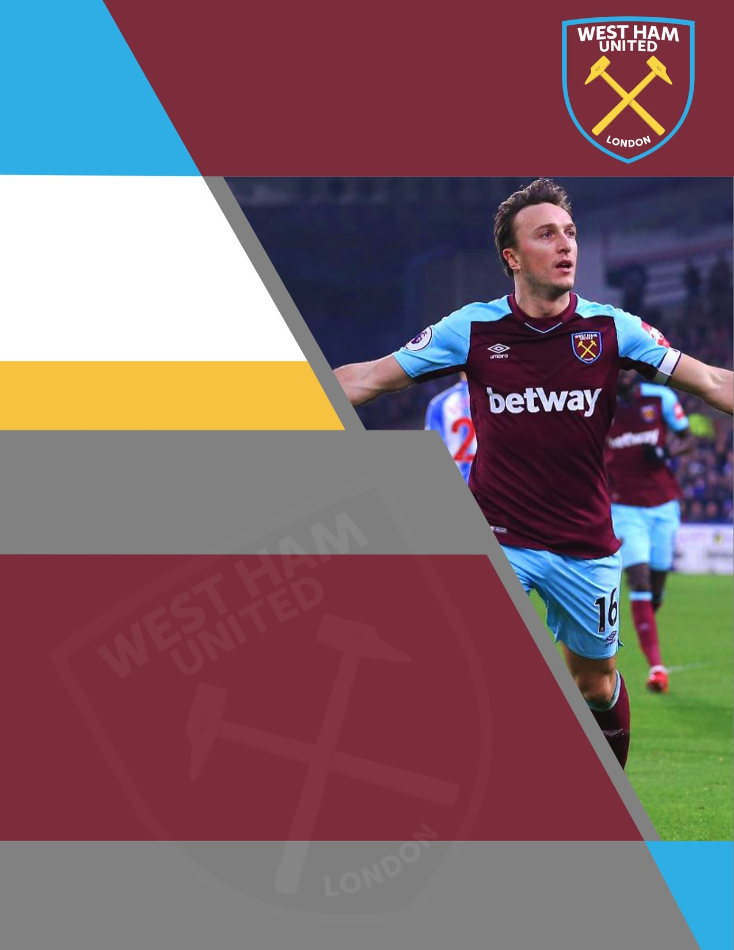REGISTRATION CLICK HERE

Phone: 0434 413 140

www.globalimagesports.com

